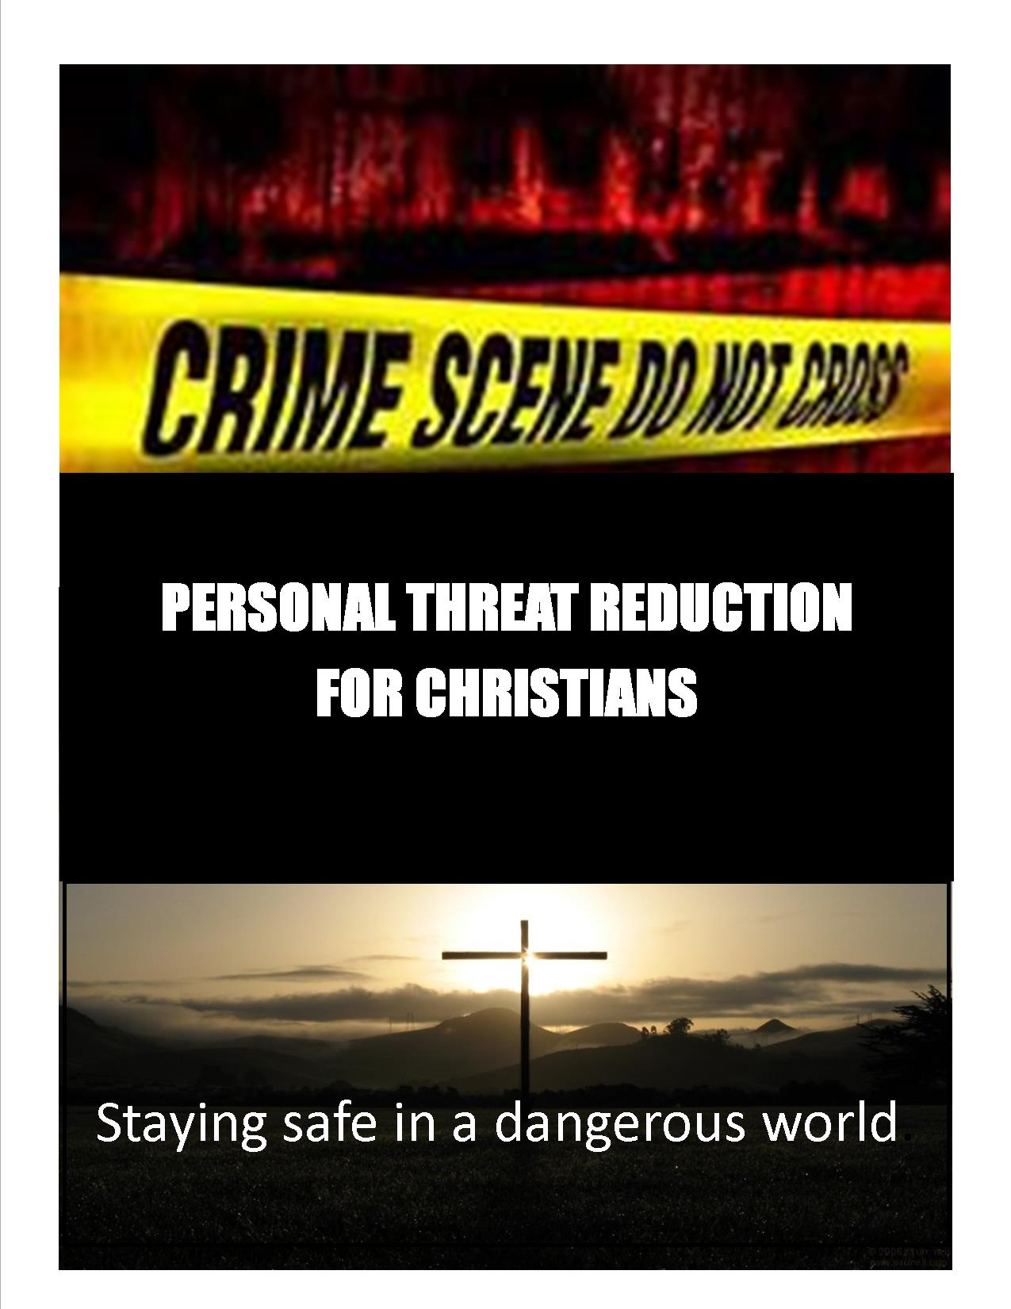

**Personal Threat Reduction for Christians**

**Staying Safe In A Dangerous World**

What measures should we as Christians take to safeguard ourselves against criminal assault? In a recent report on crime in the United States, the Federal Bureau of Investigation announced that someone is the victim of an aggravated assault every 29 seconds; every 5 minutes, a person is forcibly raped; and every 21 minutes, a citizen is murdered. According to the U.S. Department of Justice, the chances of being the victim of a violent crime are greater than those of being hurt in a traffic accident. Confronted with the dramatic media attention paid daily to violent crime, many Christians are asking if they should look for ways to reduce the risk of victimization.

This presentation; **Personal Threat Reduction**, is a primer for self-protection; it openly examines current trends in criminal behavior and victim response from a spiritual perspective, and explains practical techniques Christians can use to avoid harm. The presenter, Richard Martin, is the Head Elder of his local northern Nevada church congregation, a former law enforcement officer and former Fire Chief. Martin is currently the Safety Manager for a large construction corporation. He presents information from some of the best and most recent psychological, criminal justice, and security research available, in particular the mind, motivations, and methods of an assailant; the "street-proof" precautions needed to avoid a confrontation; the changes in behavior of victims or near-victims; the "vincibility scale": a measure how attractive you are to a criminal; the dangerous threats to children, the aged, and the handicapped.

Martin’s primer outlines how to avoid a criminal assault before it escalates to violence. This revealing presentation draws lessons from interviews with victims and criminals, and synthesizes the best advice of crime researchers, psychologists, and self-defense professionals. Personal Threat Reduction is a revealing exploration of the real world fact of violence, biblical Christian response, and factors that make a person vulnerable to a criminal act and the motivations provoking stranger assault.

Faith, fear, trust and preparation are all presented with scriptural references in a non-denominational, non-proselytizing factual format. Attendees are given proven steps that can be taken to make anyone less likely to be a victim of violent crime.

We wear seat belts to protect us from harm in automobile accidents, we have air bags to lessen the risk of injury in auto crashes, yet the probability of being a victim of a violent crime is greater than that of a vehicle accident. Are we taking appropriate precautions? What would God have us do?