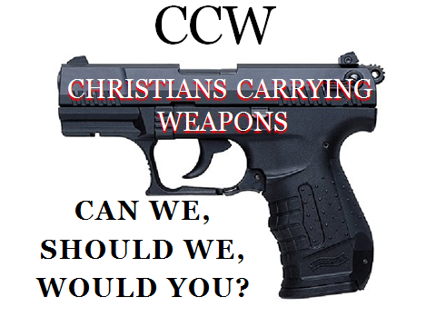

**A scripture based presentation on the subject of Christians carrying weapons. Non-denominational and non-advocating, this presentation simply explores the scriptural perspectives and history of this issue.**

**Where : ???**

**When : ???**

**In a time of intense debate surrounding gun control, and in a period of increasing crime and violence, this subject is on the minds of many Christians. Quiet conversations occur every day as believers explore both feelings and scripture in regards to the topic.**

**This presentation brings the discussion out in the open. Without advocating a position for or against, scriptural references and historical information are provided for individual contemplation. While the issue of Christians and weapons provides the backdrop for the presentation, a personal relationship with Christ and a living experience with Holy Scripture are the common thread throughout the evening.**

**Can We – the legal question**

**Should We – the moral / scriptural question**

**Would You – the personal question**

**The presenter for this program is an elder in his church, a former law enforcement officer, former Fire Chief, and currently the Director of Risk Management and Loss Prevention for a Nevada corporation. He brings the perspective of experience, the witness of human struggles, and the reality of today’s world to the presentations information.**

**No church doctrine, no denominational emphasis, just a scriptural exploration of the questions many have asked in this regard.**